**Access s3 bucket using role via ec2**

1. **Instance launching**

* **Launch instance**

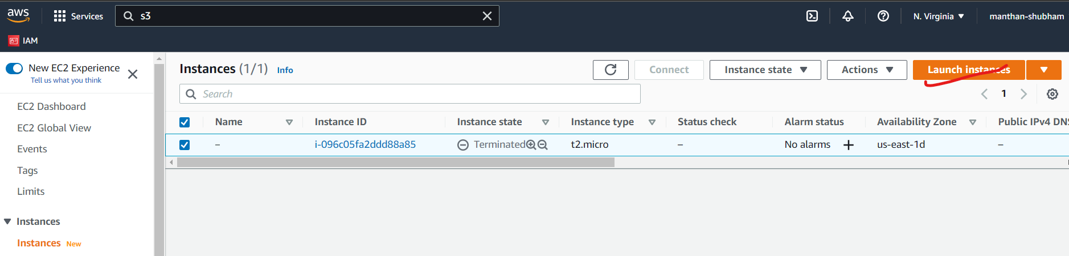

* **Select machine**

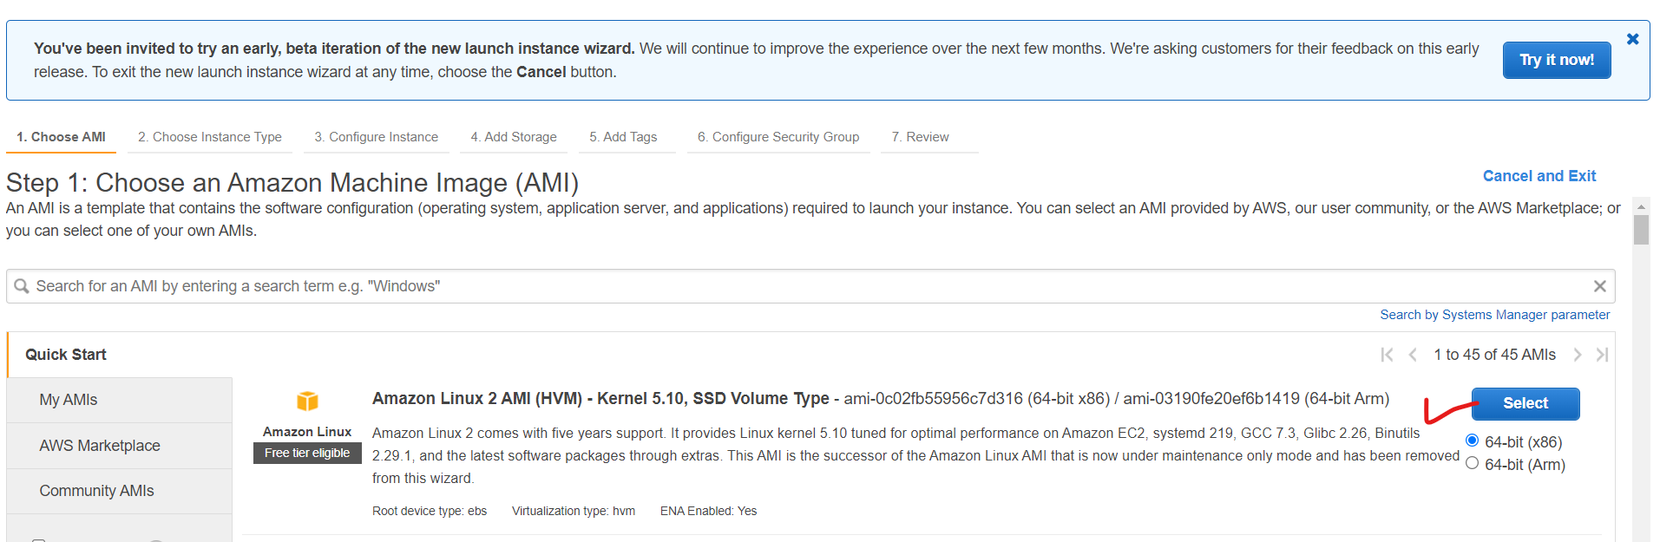

* **Select instance type**

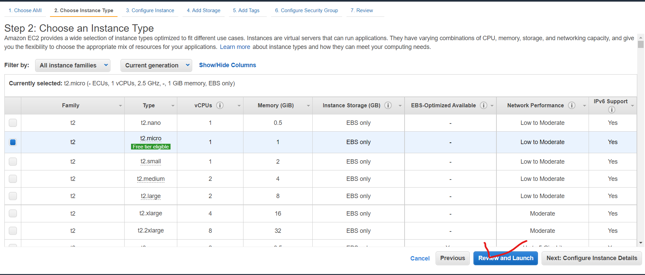

* **Launch**

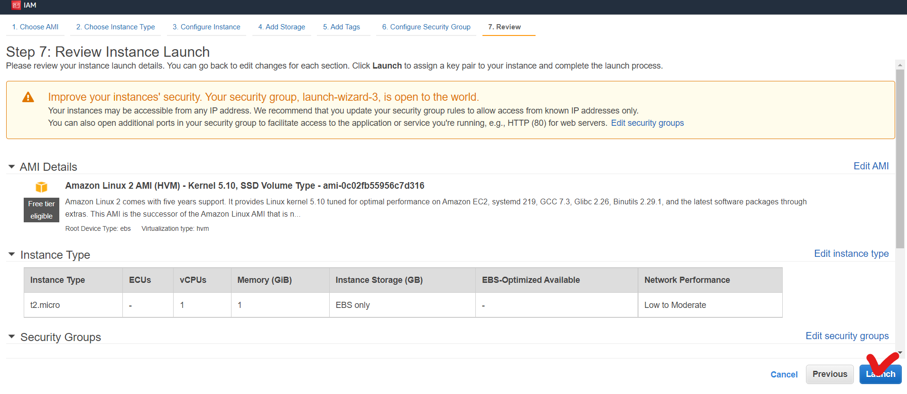

* **Download key and launch instance**

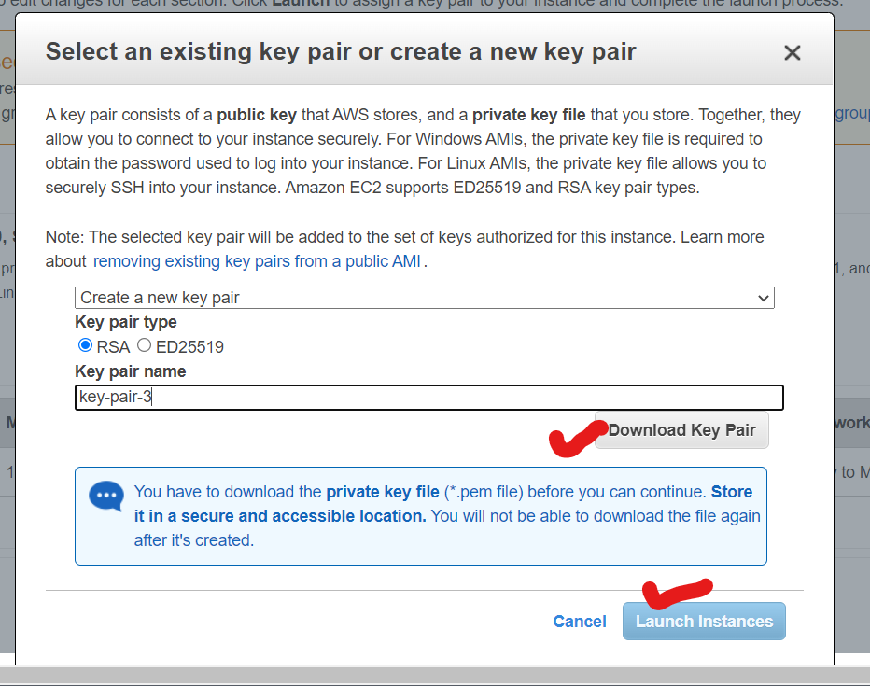

* **Give name to instance**

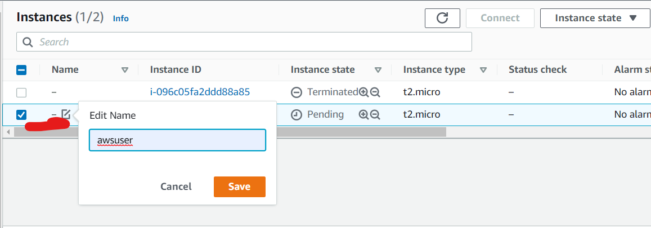

1. **Creating User**

* **Add user**

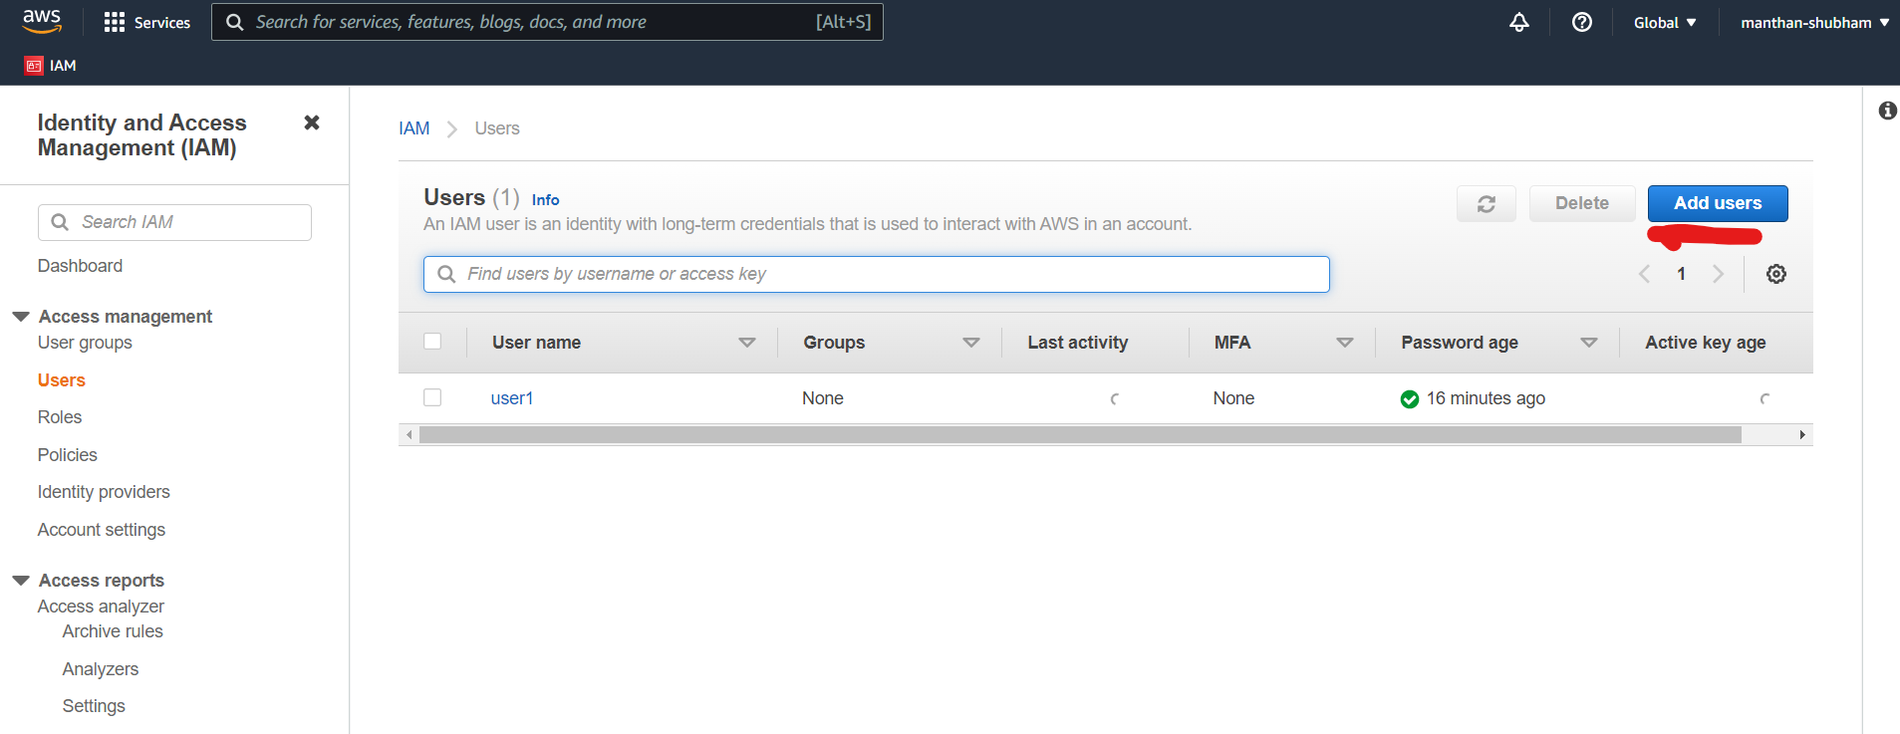

* **Add user details & mark access key**

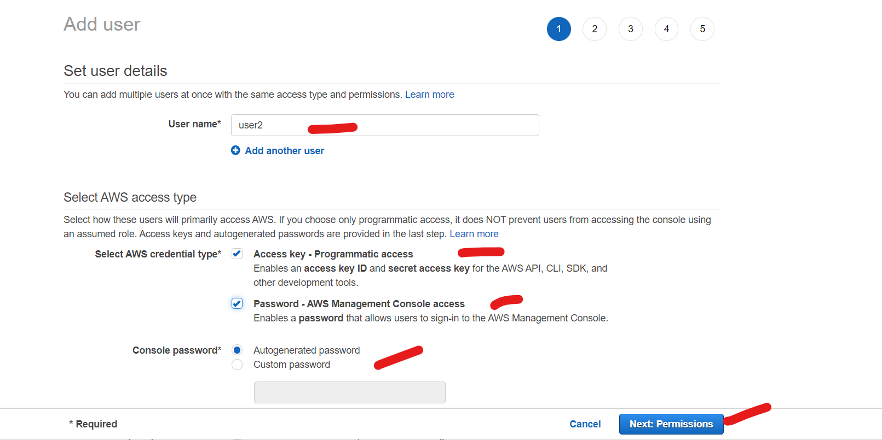

* **Assign permission S3FullAcceess & ec2FullAcceess**

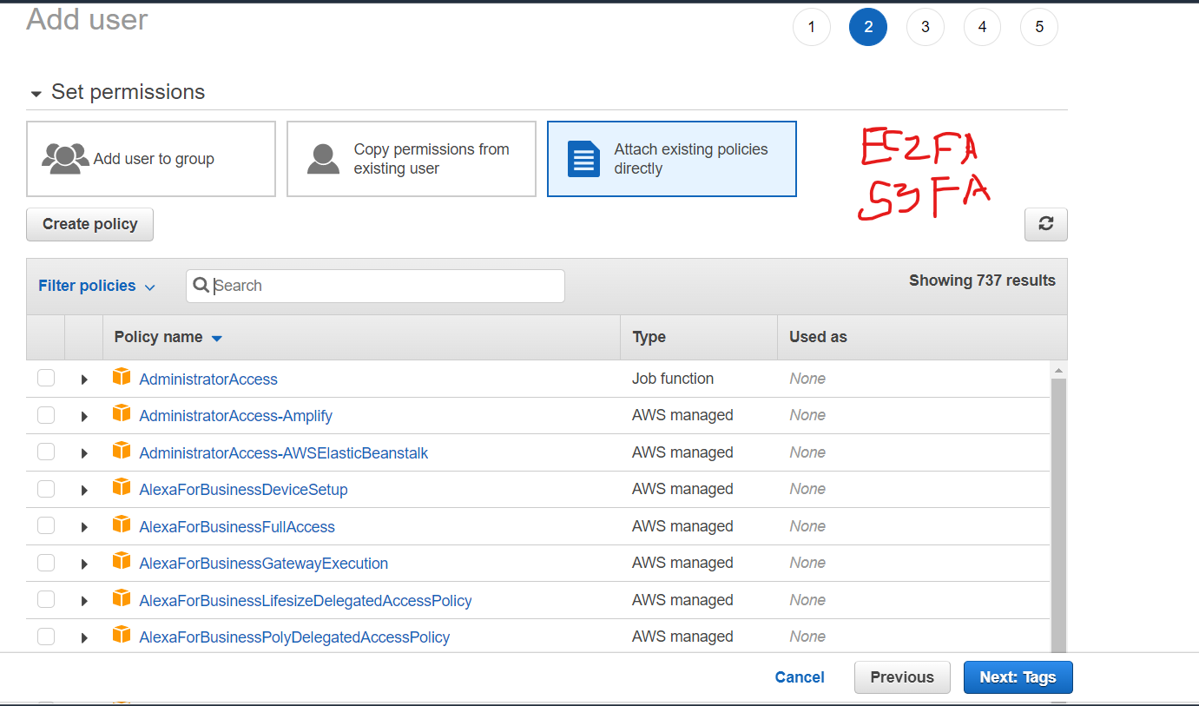

* **Creating user**

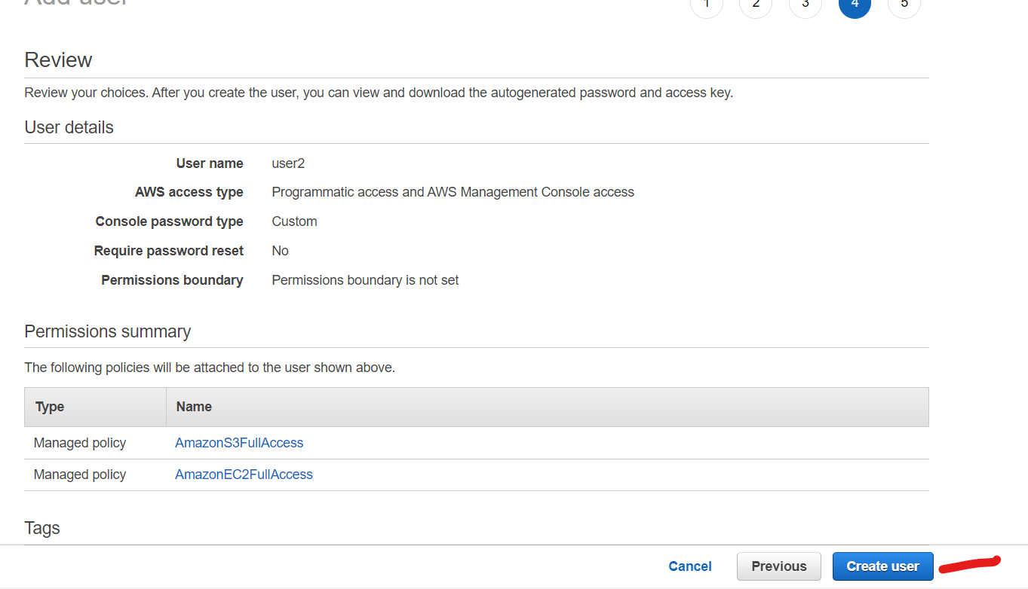

* **Download credentials**

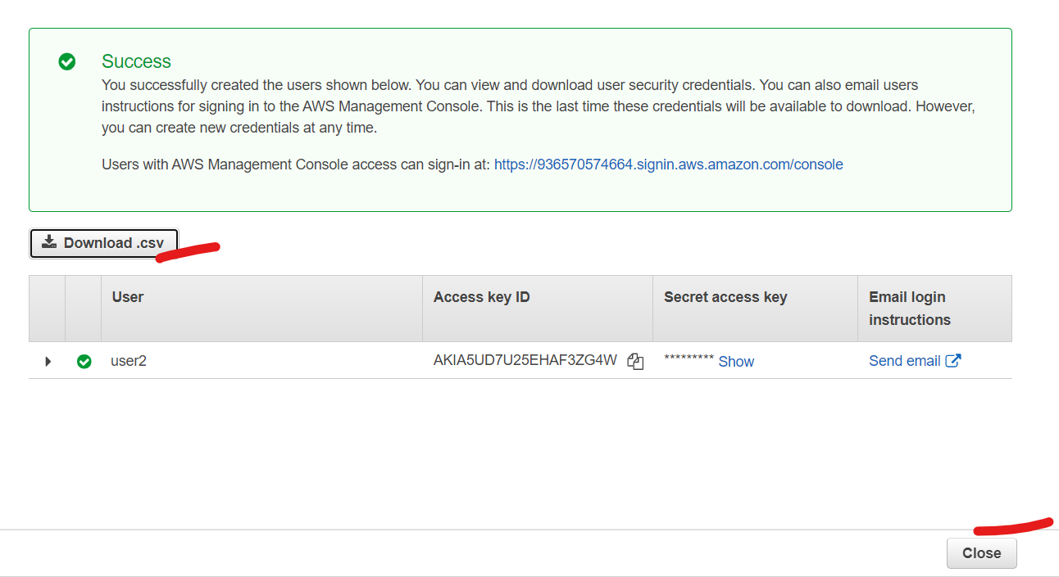

1. **Creating Bucket**

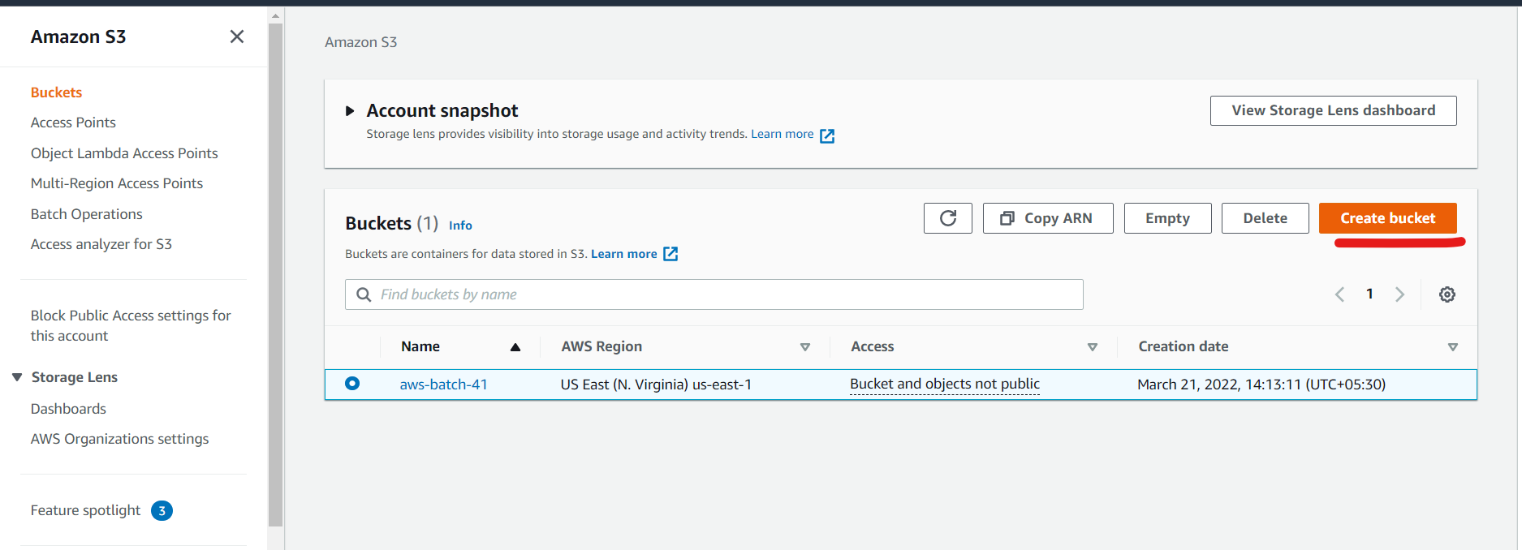

* **Assign name to bucket**

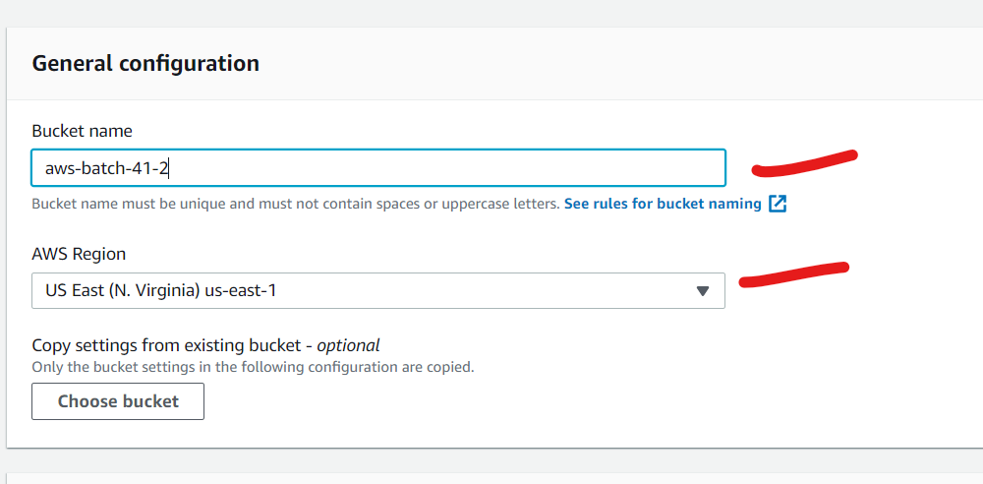

* **Create bucket**

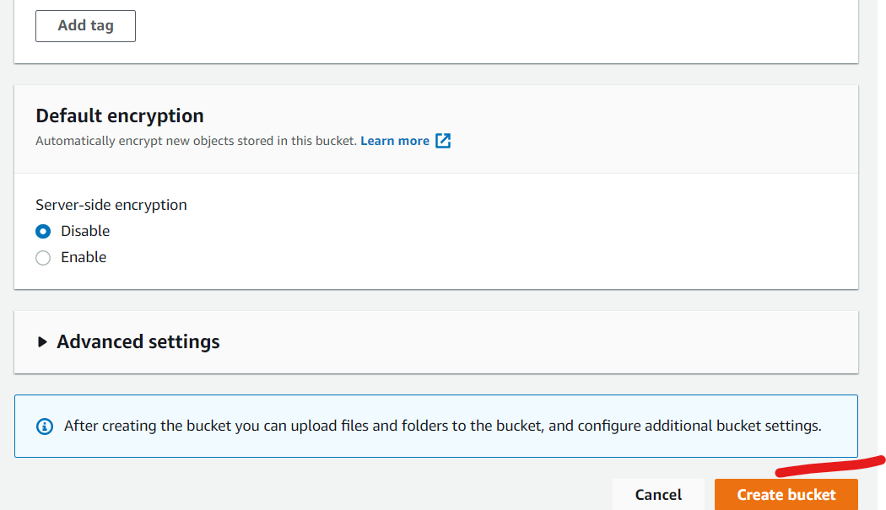

1. **Login with moboxtreme**

* **Copy public IP of instance**

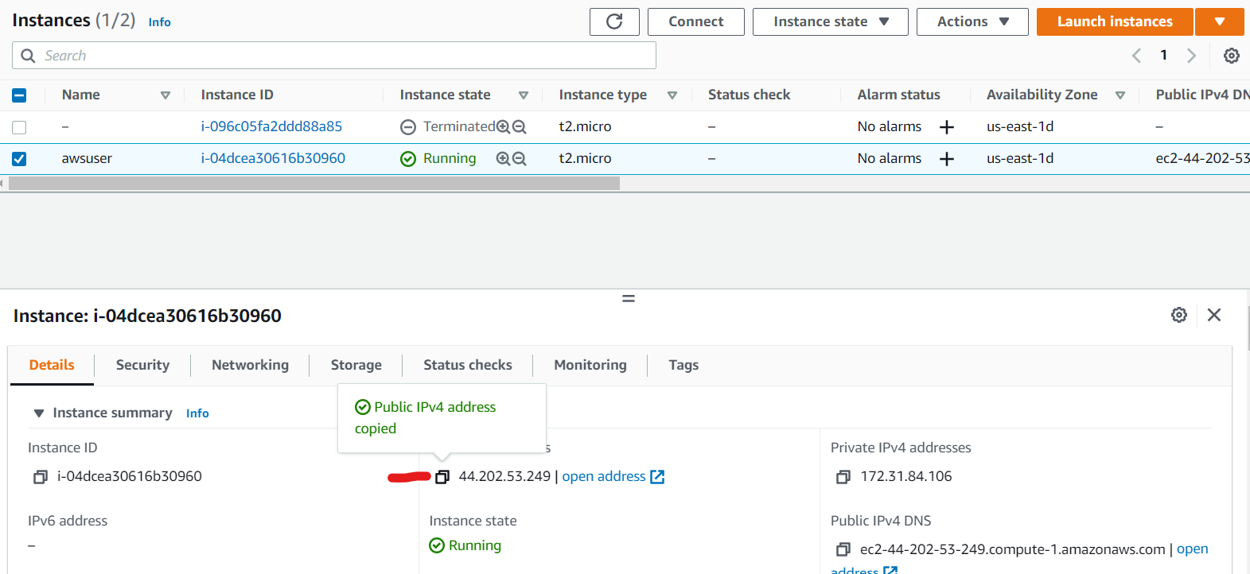

* **Open moboxtream** 🡪**session** 🡪 **SSH**

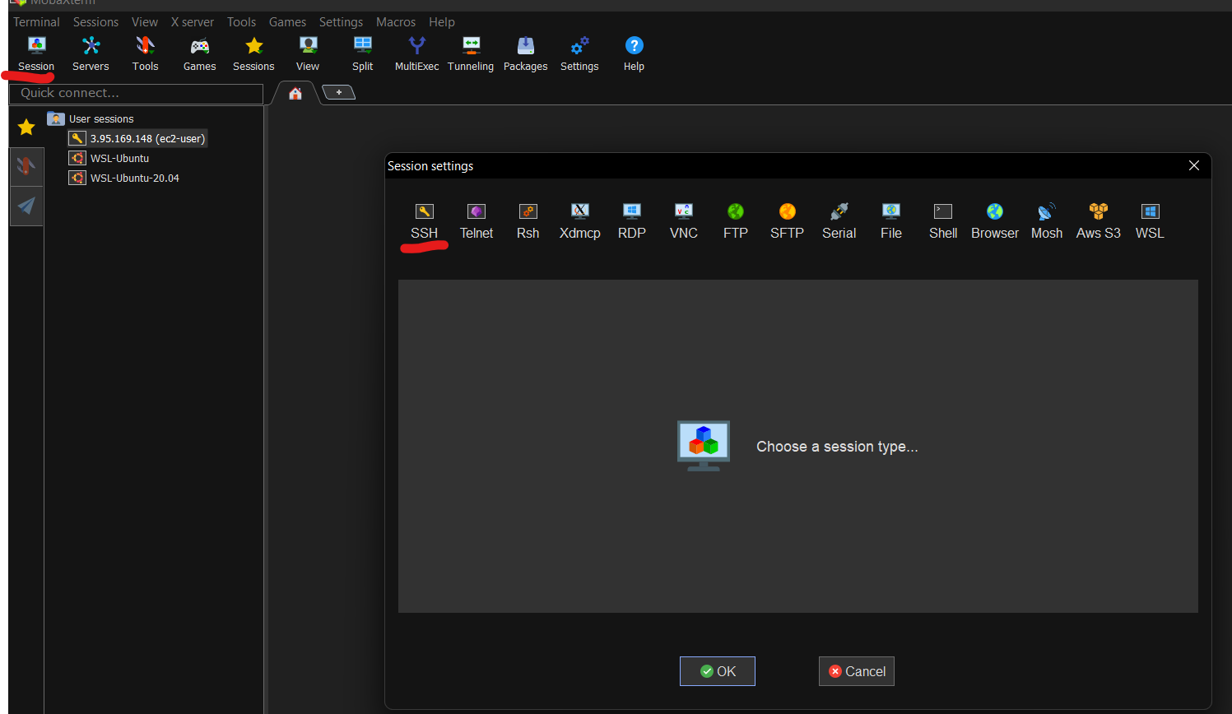

* **Fill details**

**Remote host 🡪 copied public IP of instance**

**Username 🡪 ec2-user**

**Private key 🡪 downloaded key when launching instance**

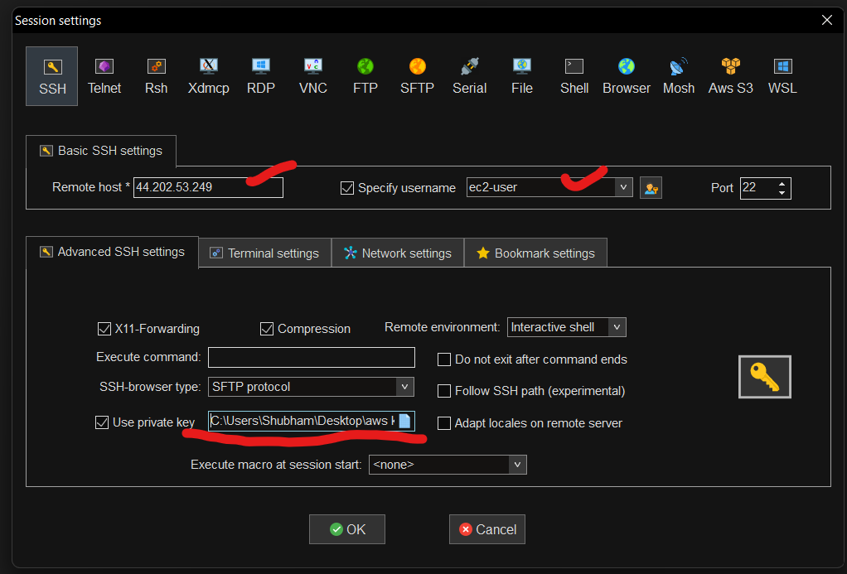

**Aws access key id 🡪 access key from downloaded credentials**

**Secrete key 🡪 from download credentials**

